**CSE 230: DISCRETE MATHEMATICS**

**MID TERM EXAMINATION: FALL 2018**

**TIME: 1 HOUR MARKS: 50**

**ANSWER ANY 05 (FIVE) OF THE FOLLOWING 06 (SIX) QUESTIONS  
[N.B.: TO UNDERSTAND THE QUESTIONS IS A PART OF EXAMINATION]**

|  |  |  |
| --- | --- | --- |
| **NAME:** | **ID:** | **SEC:** |

|  |  |  |  |
| --- | --- | --- | --- |
| **1.** | **a)**  **b)** | You have three boxes of fruit. One contains just apples, one contains just oranges, and one contains a mixture of both. Each box is labeled -- one says "apples," one says "oranges," and one says "apples and oranges." However, it is known that **none of the boxes are labeled correctly**. How can you label the boxes correctly if you are only allowed to take and look at **just one piece of fruit** from **just one of the boxes**?  You are given eight jelly doughnuts. The doughnuts all weigh the same amount **except for one which is heavier**. You have a balancing scale at your disposal. What's the **minimum** number of weighings required for you to pick out the heavy doughnut every time? | [6]  [4] |
| **2.** | **a)** | Express the following statements using predicates and quantifiers (State necessary propositional functions first ) :   1. Every student in your class either studies Java or C++. 2. Some students in your class have not studied Java. 3. Students in your class who did not pass in Java must study C++. | [6] |
|  | **b)** | Determine the truth value of each of these statements for $x ∈R$. You just need to write either **True** or **False**.  i) $∀_{x}(x≤0 →x≤x^{2})$ ii) $¬∃_{x}\left(x+1<x\right)$ | [4] |
| **3.** | **a)** | Prove that $\sqrt{13}$ is irrational using proof by contradiction. | [5] |
|  | **b)** | Show that $(n↔m$**)** and $(\left(n∧m\right)∨\left(¬n∧¬m\right))$ are logically equivalent. | [5] |
| **4.** | **a)** | Determine whether each of these functions is a *bijection* for $x: R→R$ $f(x) = 2x + 1$ $f\left(x\right)= x^{3}$ $f\left(x\right)=\frac{x^{2}+ 1}{x^{2}+ 2}$ | [6] |
|  | **b)** | For each of the following sets, determine whether 5 is an element of that set. You just need to write **Yes** or **No**.   1. } | [4] |
| **5.** | **a)** | Use the summation notation to rewrite the following series: $$1^{2}-2^{2}+3^{2}-4^{2}+5^{2}-6^{2}+…+{2001}^{2}-{2002}^{2}+{2003}^{2}$$ | [4] |
|  | **b)** | The standard method for telling time is to split the day into two 12 hour segments. Instead of counting up to 24, we count to 12 twice. This is called **circular counting,** which is a fundamental representation of modular arithmetic. Furthermore when you convert between military time and standard time, you are performing modular arithmetic. For example, we know that 15:00 is the same as 3:00 PM because when we divide 15 by 12, we’re left with 3 as a remainder. Can you figure out what time would it be right now in a universe that uses modulus 8 in their time system instead of 12? So, if it is 9.00 PM in our universe, what time would it be in that universe? | [6] |
| **6.** | **a)** | Primes in arithmetic progression are any sequence of at least three prime numbers that are consecutive terms in an arithmetic progression. An example is the sequence of primes $(3, 7, 11).$ In 2004, Terence Tao from Australia and Ben Green from the UK proved that there are arithmetic sequences of primes of any given length. For this and other work, Tao in 2006 became the first Australian to be awarded a Fields Medal, which is considered to be equivalent to a Nobel Prize in Mathematics.   1. Find an arithmetic progression of four primes with **common difference** of 14? 2. Can you explain why $(3,5,7)$ is the only arithmetic progression with **common difference of 2**?   **N.B: See Appendix A for a list of all prime number up to 1000.** | [4]  [3] |
|  | **b)** | A parking lot has 31 visitor spaces, numbered from 0 to 30. Visitors are assigned parking spaces using the hashing function, $$h(k) = (k mod 100) mod 31,$$ where $k$ is the number formed from the first three digits on a visitor's license plate. Which spaces are assigned by the hashing function to cars that have the following first three digits on their license plates? $$317, 918 ,007$$ | [3] |

**APPENDIX**

1. **List of all prime numbers up to 1000**

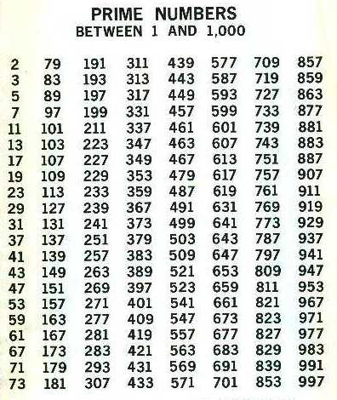

1. **Set Notations**

$R -The Set of Real Numbers$

$$Q -The Set of Rational Numbers$$

$$N -The Set of Natural Numbers$$

$$Z -The Set of Integers$$

$${ Z}^{+}-The Set of Positive Integers$$